Largest:
[org 0x0100]

jmp start

num : dw 2,4,5,19,7,8,17,6

max: dw 0

secondlargest: dw 0

secondlargesttt:

mov dx, [num+bx]

mov [secondlargest] ,dx

sub cx, 1

jnz compareloop

jz terminate

nextlargest:

mov dx, ax

mov [secondlargest] ,dx

mov ax ,[num+bx]

mov [max],ax

add bx ,2

sub cx,1

jz terminate

jnz compareloop

start:

mov ax ,[num]

mov [max] ,ax

mov bx ,2

mov cx,8

compareloop:

cmp ax,[num+bx]

JNAE nextlargest

cmp [num+bx] ,dx

ja secondlargesttt

add bx ,2

sub cx,1

jnz compareloop

jz terminate

terminate:

mov ax ,0x4c00

int 0x21
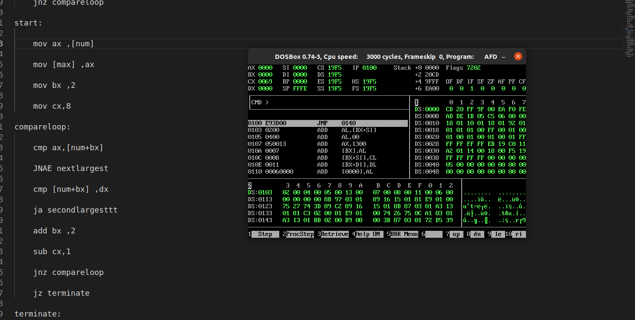

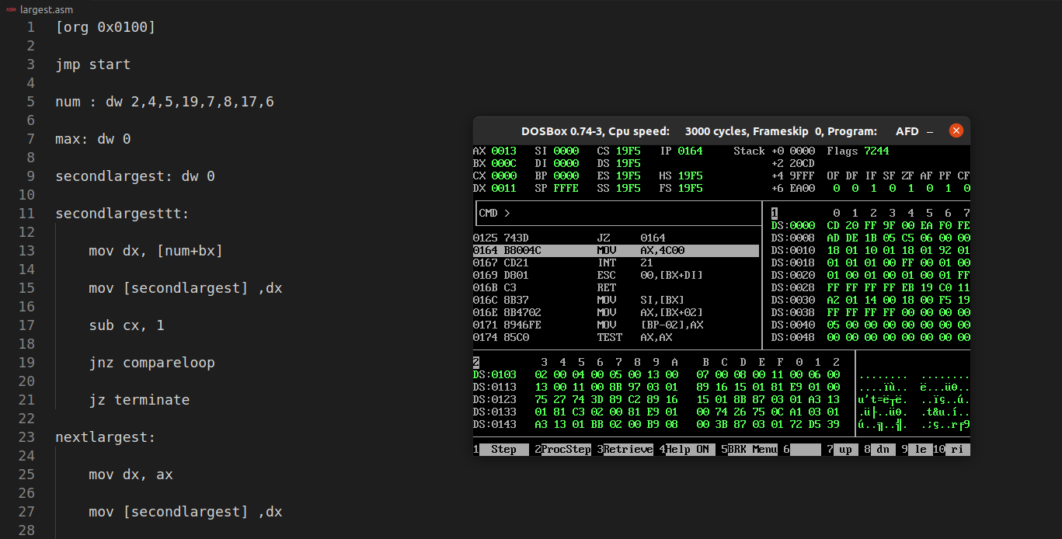
.

Second Smallest:
[org 0x0100]

jmp start

num : dw 12,4,5,19,1,2,17,6

small: dw 0

secondsmall: dw 0

secondsmallest:

mov dx, [num+bx]

mov [secondsmall] ,dx

sub cx, 1

jnz compareloop

jz terminate

nextsmall:

mov dx, ax

mov [secondsmall] ,dx

mov ax ,[num+bx]

mov [small],ax

add bx ,2

sub cx,1

jz terminate

jnz compareloop

start:

mov ax ,[num]

mov [small] ,ax

mov bx ,2

mov cx,8

compareloop:

cmp ax,[num+bx]

JAE nextsmall

cmp [num+bx] ,dx

jb secondsmall

add bx ,2

sub cx,1

jnz compareloop

jz terminate

terminate:
mov ax ,0x4c00

int 0x21


